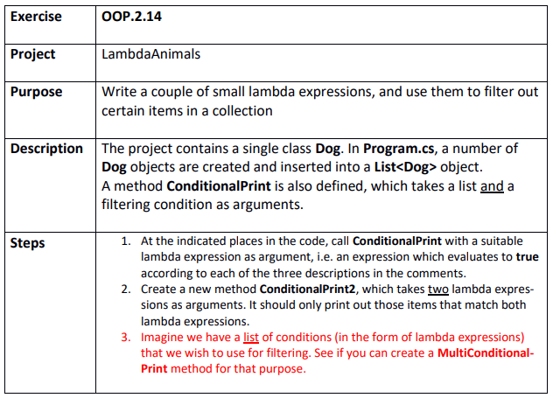

Step 1
C:\Git\OOProg25\Chap\OOProg02\MySolution\OOP.2.14 - LambdaAnimals\LambdaAnimals\LambdaAnimals.sln
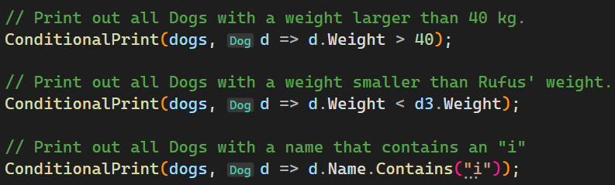

Step 2
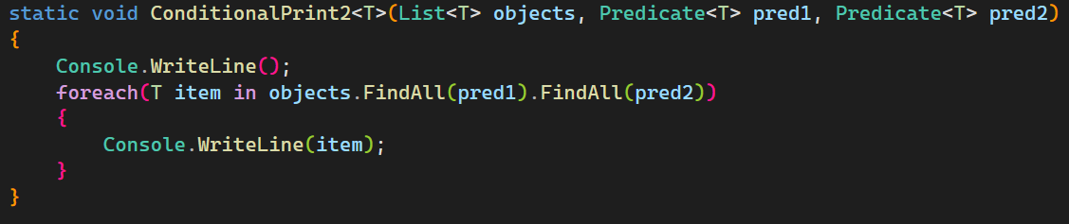

Step 3
